# Diabetes Classification Results using RandomForest

## Classification Report:

precision recall f1-score support  
  
 0 0.83 0.74 0.79 149  
 1 0.77 0.85 0.81 151  
  
 accuracy 0.80 300  
 macro avg 0.80 0.80 0.80 300  
weighted avg 0.80 0.80 0.80 300

## ROC AUC Score:

ROC AUC Score (RandomForest): 0.8593493044135294

## ROC Curve:

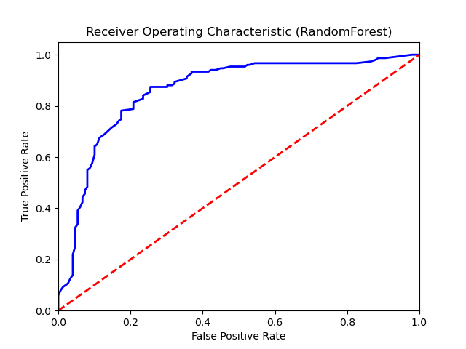

## Confusion Matrix:

True Negatives: 111

False Positives: 38

False Negatives: 22

True Positives: 129

## Confusion Matrix Plot:

